CONNECT Feature Request – UOM conversion
Unit of Measure (UOM) standards are commonly used in the Energy and Manufacturing industries. Lack of the ability to convert UOM in CONNECT is seen as a “showstopper” for ExxonMobil in using CONNECT as their main operational Cloud platform. The conversion may apply for a few million streams, or parameters on the streams, over a long reporting period (2+ years). As such, UOM conversions are not a “one off” but a frequent conversion for large amounts of data.
The “WHY”: There are multiple reasons why UOM conversions are essential for software applications:
1. Standardization and Consistency - To ensure consistency in communication where standard units (like SI units) are expected.
2. Compatibility - To match units when combining or comparing measurements.
3. Ease of Interpretation - Some units make values more understandable or practical (e.g., converting 0.0005 km to 0.5 meters makes it more intuitive).
4. Precision and Accuracy - To express a measurement in the most appropriate unit for the required precision (e.g., micrometers for fine machining tolerances).
5. Regulatory or Legal Requirements - Certain industries or countries may mandate the use of specific units (e.g., metric units in most countries for packaging labels).
6. Contextual Relevance - Some units are more relevant to specific fields or everyday use (e.g., using inches for screen sizes in the U.S. vs. centimeters in Europe).
7. Convenience - To simplify calculations
For many of the reasons above ExxonMobil uses 2 main UOM conversion standards for EVERY SITE which need to be applied to their parameter data in CONNECT data services.
The “WHAT”:
The actual measured value for any parameter/stream on any element for an Asset, from any source, should be stored in CONNECT data services “as is” due to data integrity of the raw data. However, the raw data frequently needs to be exposed for multiple Use Cases, and to multiple user groups, in a different UOM than the measured UOM. As such, a parameter on a stream can be requested to be converted to multiple other UOMs from different user groups within a company.
The definition of the UOM conversion should be set at a low/detailed level. Commonly the parameter in an element or stream needs to be converted. The conversion can be as simple as converting Degrees Fahrenheit or Celsius or Pressure measured in Bar converted to PIS or kPa.
UOM conversion needs to be available for use inside CONNECT applications – specifically visualization, for data platform integration (Power BI, Seeq, Databrick etc.) and Communities.

UOM conversions are often standardized per company and industry. The most common for the Energy industries are;
Organization | Relevant Standard
SI (International System of Units) | Global metric system
API (American Petroleum Institute) | Oil and gas measurement standards
ISO (International Organization for Standardization) | E.g., ISO 5167 for flow measurement
IEC (International Electrotechnical Commission) | Electrical measurement standards
OIML (International Legal Metrology) | Legal standards for measuring instruments

The ability to convert between the standards in CONNECT would be most useful. For example, converting from the metric system to the Oil and gas measurement standards:
Measurement | SI Unit (Metric) | API Standard / Common U.S. Unit | Conversion Factor
Length | meter (m) | foot (ft) | 1 m = 3.28084 ft
Volume | cubic meter (m³) | barrel (bbl) | 1 m³ ≈ 6.28981 bbl
Mass | kilogram (kg) | pound (lb) | 1 kg = 2.20462 lb
Energy | joule (J) | British Thermal Unit (BTU) | 1 J ≈ 0.000947817 BTU
Pressure | pascal (Pa) | pounds per square inch (psi) | 1 Pa ≈ 0.000145038 psi
Temperature | Celsius (°C) | Fahrenheit (°F) | (°C × 9/5) + 32 = °F
Density | kg/m³ | lb/ft³ | 1 kg/m³ ≈ 0.06242796 lb/ft³
Flow Rate | m³/day | barrels per day (bpd) | 1 m³/day ≈ 6.28981 bpd
Viscosity | centipoise (cP) | centipoise (cP) | 1 cP = 1 cP (identical unit)
API Gravity | — | degrees API | °API = (141.5 / SG at 60°F) - 131.5

“The HOW”:
UOM conversion is most common for measured values but can also be applied to meta data. As such, the ability to define a conversion must be for parameters, streams, assets and entities.
We can possibly utilize the existing ability in CDS to Configure UOMs for streams/parameters:
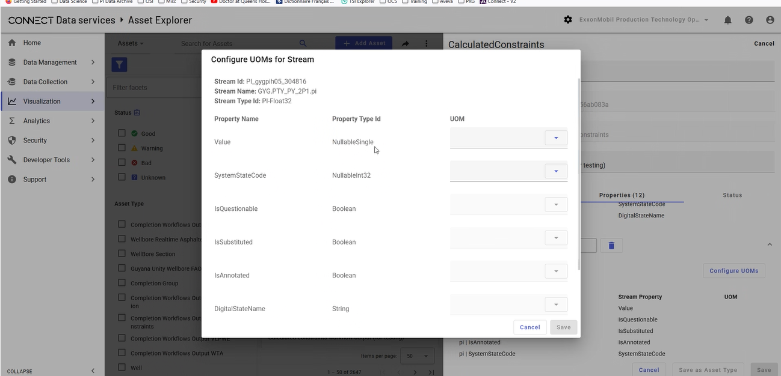
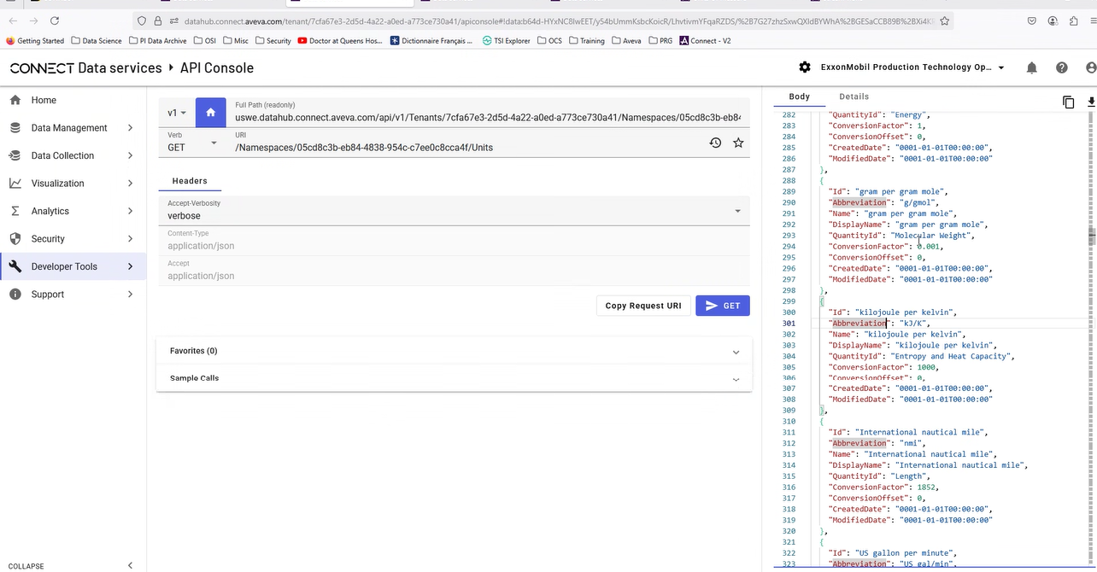
Ideally, we also have a place to import/define the UOM standards within CDS.
Ad hoc or “on the fly” conversion.
When the required UOM standards are added/defined on the streams in CDS they should be available for use by DataViews, Connect Visualization, Communities and Connectors etc.
Example: Today the DataView column shows the raw data measured e.g. heading is “BHPA Value bar”. With UOM conversion enabled the DataView column can be configured to be a different UOM for example: “BHPA Value PSI”. As such, the configuration of the DataView UOM will trigger the conversion prior to displaying the data in the DataView.
